Council of Community Services Salvation Army
114 4J Road 222 S Gillette Ave Suite 608
Gillette, WY 82716 6th Floor, First Interstate Bank
    - 307-682-6982

Public Health Bread of Life Food & Clothing Pantry
4-J Road Open Door Church 685-3337
Gillette, WY 82718 111 E 2nd St Gillette, WY
682-7276 2nd & 4TH Thursdays 10-11:30a.

Wyoming Work Force Department of Family Services
551 Running W Drive 551 Running W Drive
Suites 100 & 300 Suite 200
Gillette, WY 82718 Gillette, WY 82716
307-682-9313 307-682-7277
Social Security Thur. 10am-3pm Website: dfsweb.state.wy.us
Website: wyomingatwork.com

DVR Short Term Employment
Dept. of Vocational Rehabilitation Addeco 686-1124
551 Running W Drive Manpower 682-8796
Suites 100 & 300
Gillette, WY 82718
682-2672

Colleges
North West Community College – Gillette Campus
West 300 Sinclair 307-686-0254
Diesel Technology 686-0254 Ext. 1161
Welding Technology 686-0254 Ext. 1164
I-Tec 686-0254 Ext. 1167

For Area Events and Information
Gillette News Record
www.gillettenewsrecord.com

Second Chance Ministries’ mission is to walk along side men and women released from incarceration into our community. Our mission is to provide re-entry assistance to our clients and to help men and woman rebuild their lives on the foundation of God’s Word. While Second Chance Ministries is a faith based ministry, we do not refuse services to anyone meeting our criteria, nor do we proselytize.

AA Locations
Blue Building 2910 S Douglas Hwy Open Sun. thru Sat.

Strugglers 200 W Lakeway/Methodist Church Mon. and Thur. 8:00pm

The Vineyard 8:00pm Thursday
Contact: 307-660-1968 7:30pm last Thursday of month
AA 24 Hr Answering Service 686-6107

NA Locations
The Refuge 114 4-J Rd Mon. Wed. Friday 5:30-6:30 pm
Tuesday 8-9p.m. Thursday & Sat. 9-10pm
Lost and Found 5001 Tanner Dr. Thursday Noon Sun. 3pm

12 Step Faith Based Recovery Group
Second Chance Ministries
Life Recovery Group
Sundays 5-6 p.m.
706 Longmont Street
Gillette WY 82716
307-682-3148
Celebrate Recovery
Assembly of God
Thursday 6:00-9:00p.m.
601 Carey Ave.
Gillette, WY 82716
(307) 682-3308

IOP Services Available
A Positive Solution Counseling Center, LLC Patricia Nesbit
201 W. Lakeway Rd, Suite 1004 601 S. Gillette Ave.
Gillette, WY 82718 Gillette, WY 82716
307-682-3747 307-685-8182
Brighter Horizons Counseling, LLC
113 S. Gillette Ave., Suite 203 Personal Frontiers, Inc.
Gillette, WY 82716 310 S. Miller, Suite G
    - Gillette, WY 82716
    - 307-686-1189
Clear Creek Counseling
801 East 4th Street, Suite 24
Gillette, WY 82716
307-686-9422

My Chains are gone
I’ve been set free
My God, my Savior has ransomed me
And like a flood His mercy reigns
Unending love, Amazing grace.

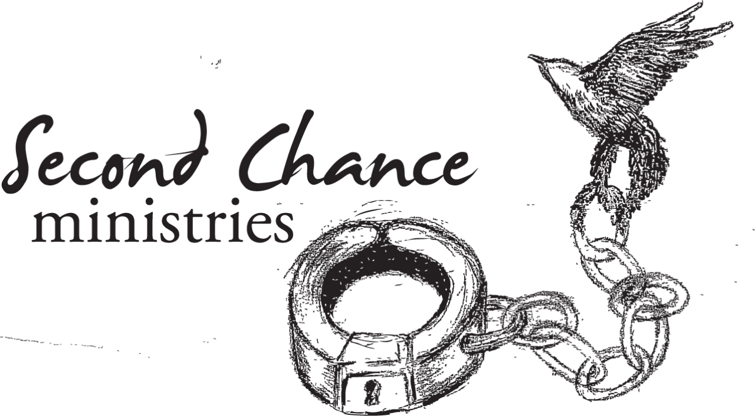

Prisoner Re-Entry
Services
706 Longmont Street
Gillette, WY 82716
307-682-3148
secondchancegillette.org

We believe we should: Feed the hungry,
Clothe the naked, Welcome the stranger,
Visit the incarcerated, and Serve the least of these.
Matthew 25:34-40

Community Resource
Client Brochure
Area Churches

First Assembly of Assembly of God
God Church Family Life Center
6th & Carey Ave 514 Bison Ave
Gillette, WY Wright, WY
307-682-3308 307-464-1182

Central Baptist Church First Baptist Church
1170 Country Club Rd 501 S Gillette Ave
Gillette, WY Gillette, WY
307-682-2543 307-682-4816
www.gillettefirstbaptist.org
Jericho Baptist Church Calvary Missionary
211 S Brooks Ave 600 E Longmont
Gillette, WY Gillette, WY
307-686-5626 307-682-9779

Antelope Valley Baptist Faith Community
2801 Antler Rd 177 American Rd
Gillette, WY Gillette, WY
307-682-1602 307-682-7333

Westside Baptist Church First United Methodist
604 West 10th St 2000 W Lakeway Rd
Gillette, WY Gillette, WY
307-682-3505 307-686-7339

Living Rock Church Roadway Alliance
1001 S Douglas Hwy 811 Hemlock Ave
Gillette, WY Gillette, WY
307-670-1518 307-686-7738
www.livingrockgillette.com

St. Matthew’s Catholic Open Door Church
900 Butler Spaeth Rd 111East 2nd St
Gillette, WY Gillette, WY
307-682-3319 307-685-8180

Church of Christ First Christian Church
1204 T-7 Rd 100 E Flying Circle Dr
Gillette, WY Gillette, WY
307-682-2528 307-682-3316

Corner Stone Church of God Journey Church
406 S Brooks 3601 Southern Drive
Gillette, WY 82716 307-257-8311
307-686-6429 Gillette, WY 82718
journeychurchgillette.com

Calvary Community High Plains Community
631 Commercial Dr 3010 W. Lakeway Road
Gillette, WY Gillette, WY
307-682-9553 307-685-0044

Holy Trinity Episcopal Church of the Nazarene
804 Emerson 3010 W. 4-J Road
www.holytrinity.collinscom.net Gillette, WY
307-682-4296 307-682-2562

Gillette Christian Center Family Life Church 6201 Swanson Rd 480 S Hwy 50
www.gillettechristiancenter.com Gillette, WY
307-686-6680 307-687-1083

The Barn Abundant Life United
2 McKenzie Rd. 1612 E Hwy 14-16
Gillette, WY Gillette, WY
307-685-2272 307-687-0074

Christ Our Redeemer Peace Lutheran Church Lutheran Church 203 W Flying Circle Dr
1010 W Beaver Dr Gillette, WY
Gillette, WY 307-682-4509
307-686-4080

Trinity Lutheran Holy Resurrection
Church LCMS Orthodox Church
1001 E 9th St 122 S Gillette Ave
307-682-4886 Gillette, WY
www.trinity.gillette.org 307-682-3225

First Presbyterian Church Vineyard Christian Flshp
511 Carey Ave 585 Westside Dr
Gillette, WY Gillette, WY
307-682-7264 307-686-2485

New Life Wesleyan Cornerstone Ministries Church
1000 Comanche Ave 2 Belle Fouche River Road
Gillette, WY Moorcroft, WY
307-682-5642 307-756-3461
www.nlwchurch.org

Abiding Grace Lutheran Church
707 Bridger St.
Gillette, WY 82716
307-682-2355

Apartment Information

Asset Management Ranch Creek
325 E Boxelder 1211 S Douglas Hwy
307-682-4427 307-682-5621

Desert Run Apart. Cedar Ridge Apart.
1001 Desert Hills Circle 108 Bay Ave
307-687-0177 307-756-3337

Eagles Nest Apartments Squaw Valley Apt.
12201 S Douglas Hwy 900 E 12th St.
Gillette, WY Gillette, WY307-
307-682-0964 307-682-5555

Fairway Estates Sunset Inn
1020 Country Club Road 300 Rohan
307-686-9988 307-682-4047

Gillette Apartments Valley View
201 E Boxelder 325 E Boxelder Rd.
307-682-7956 307-686-6361

Indian Hills Apartments Warlow Drive Apts.
1001 E12th St 1720 W Warlow
307-682-5041 307-682-7800

J & L Rentals Willow Creek Apt.
914 EZ Street 1024 Church Ave.
307-685-6903 307-680-5110

Mountain View Apart. Wright, WY
2404 Foothills Blvd Wright Manor
307-682-1753 521 Latigo Drive
307-464-1404

Real Estate Systems South Fork Apts.
2201 S Douglas Hwy Enzi Dr.
Gillette, WY 82718 Gillette, WY
307-682-0964
Remington Village Apartments
711 Express Dr.
Gillette, WY 307-682-3882

