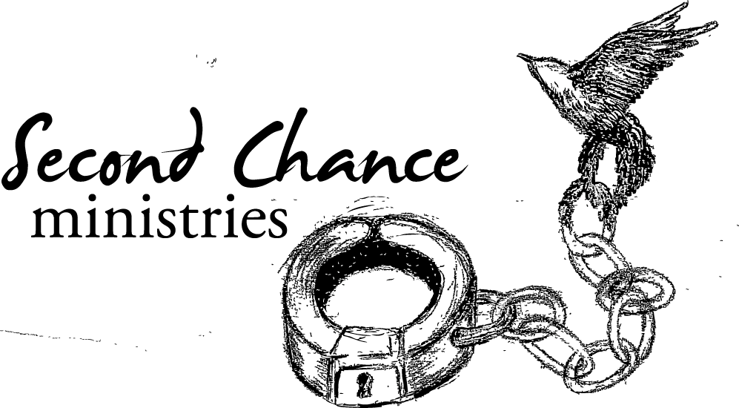

**Yes!**

I want to make a significant impact on our clients’ lives!

Enclosed is:

$100

$200

$300

$400

$500

$750

$1500

Other $

If you would like to have your gift automatically withdrawn from your bank account as an electronic funds transfer,

please call our office at (307) 682-3148.

Name: ____________________________ Address: ___________________________________________

How can we pray for you? ________________________________________________________________

*Mail this form and your charitable gift:*

**Second Chance Ministries**

**706 Longmont St.** ssdkStree

**Gillette, WY 82716**

*Your gift to Second Chance Ministries may be tax-deductible. A receipt will be mailed to you.*