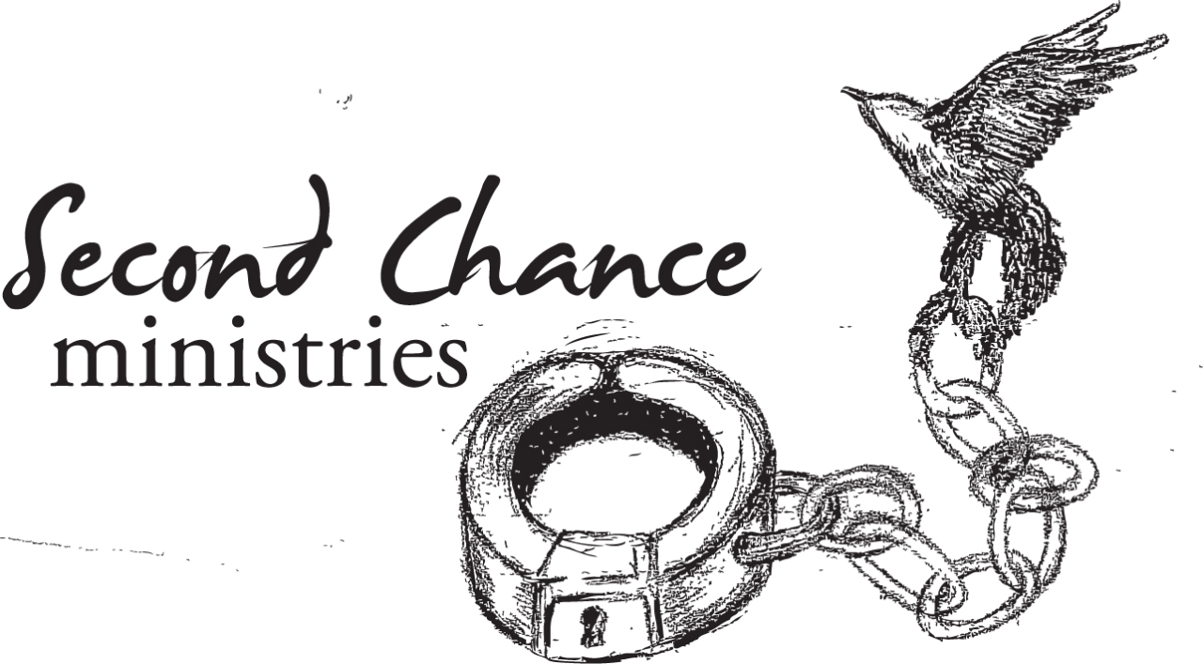

Prisoner Re-Entry Services
A community ministry reaching out with a helping hand to those coming out of incarceration into Campbell County.

We believe we should:
Feed the hungry

Clothe the naked
Welcome the stranger
Visit the incarcerated
And serve “the least of these.”
Matthew 25:34-40

Did you know:

- America has the highest incarceration rates of any nation in the industrialized world.
- Approximately 2.3 million Americans are incarcerated. Of this number, roughly 714,000 await sentencing in county jails.
- Nearly 7 million Americans are on probation, incarcerated, or on parole every year.
- US taxpayers spend $60 billion annually on corrections.
- The US currently operates about 1,745 state and federal prisons and 3,400 county jails.
- Approximately two-thirds of all released offenders will be rearrested for a new crime within 3 years.
- As of November 2005, approximately 105,000 incarcerated women were mothers.
- Close to 3,400 prisoners currently sit on death row.
- This year, about 630,000 prisoners will be released back into society.
- The first 48 hours to three months are the most critical time for former inmates in their attempt to reintegrate into society.

Behold The Fields of Harvest!
Consider joining us in bringing these men and women the transforming love of Jesus Christ.
We are not responsible for the results--only for doing our duty and persevering in God’s will.
This ministry is not only about discipleship, but it includes building relationships and being a “walk with” partner as these people step back into a society that considers them outcasts.
It is about walking beside a released prisoner during their difficult months of finding their way back into the community.
It revolves around helping men and women rebuild their lives on the foundation of God’s Word.
There are obstacles ex-prisoners must overcome as they begin their new life on the outside. Not only can we connect them with vital community and church resources, but we can also be the supportive voice that says, “I believe in you and I’ll help you make it.”
Our desire is to see transformation of ex-prisoners and their reconciliation with God, family and community through the power and truth of Jesus Christ.
The church must reach out or they have no hope. It takes community involvement for them to make it in re-entry.
While it is easy to be busy in ministry, we must ask ourselves, “what are we busy about?” and, “what is the real impact of our efforts?” Are we really making a difference?

Ministry Needs:
- Prayer…praying that God will prepare the hearts of those He will bring our way.
- Mentors…those who are willing to give time and be a “walk with” partner/discipler.
- Pen Pals…“Envelope of Hope”…
Second Chance connects with an inmate 3-4 months before their release date. A Pen Pal has the opportunity to get acquainted and become a friend/mentor, which gives an inmate a sense of pre-established support before their release.
- Cash Donations… there are specific needs ex-prisoners have. Some of these include work clothing, perishable food items, 1st month rent, pre-owned furniture, emergency medical attention, as well as other misc. needs.
- Hygiene Packs with supplies to last at least 30 days.
Packs include:
Bible
Devotional
Items needed:
*Towel & washcloth
*Shampoo & Conditioner
*Deodorant
*Disposable razors
*Shaving cream
*Toothpaste & toothbrush
*Shower Gel
*Lotion
*Comb/Brush
*Sanitary needs for the females

Training will be given to anyone taking on an ex-prisoner.

There are do’s and don’ts to any ministry.

The more informed you become the less chance of making mistakes.

Our goal is to empower volunteers that God can use for the glory of His kingdom.

If you are interested in more information or becoming a part of Second Chance Ministries, contact Tammy Akovenko.
(See contact info below.)

Second Chance Ministries
Prisoner Re-Entry Services
706 Longmont Street
Gillette, WY 82716
307-682-3148
office@secondchancegillette.org

